**Ideation Phase**

**Empathize & Discover**

| Date | 13 October 2022 |
| --- | --- |
| Team ID | PNT2022TMID52180 |
| Project Name | IoT Based Smart Crop Protection System for Agriculture |
| Maximum Marks | 4 Marks |

**Empathy Map Canvas:**

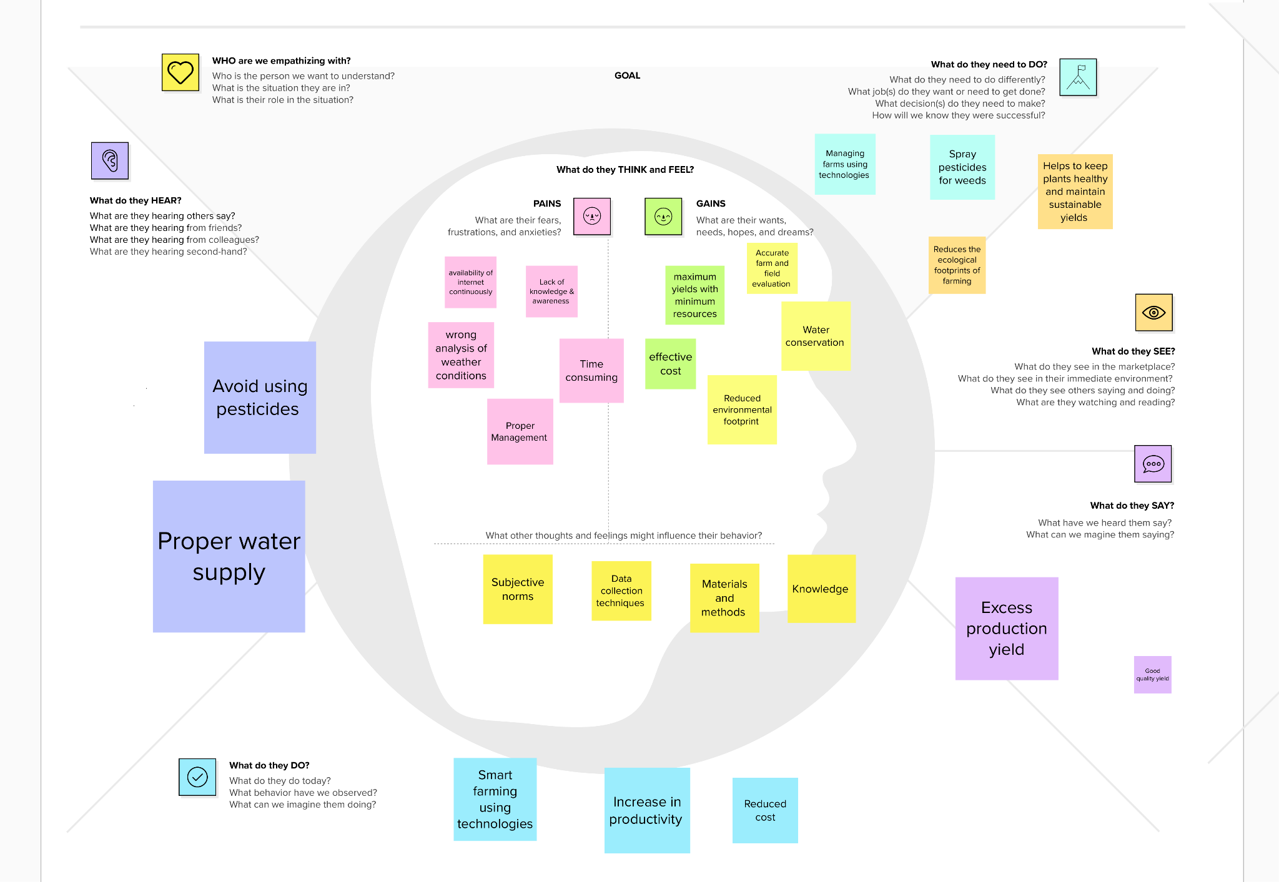

Reference:https://app.mural.co/t/sharmini2599/m/sharmini2599/1665470405133/709991fbede3761318e53ff2c487dda99940a10b?sender=u7f7a9034fe82130370029775